Dear Student and Parent,
I am writing to welcome you to Alpharetta High School Raiders Culinary Arts Pathway for the 2023-2024 school year! We are so excited to have you join our school community.

AHS Raiders Culinary is a program that is committed to providing a high-quality education for all students. We believe that every child can learn and succeed, and we are dedicated to providing the resources and support that our students need to reach their full potential.

Our program is a warm and welcoming environment where students feel safe and supported. We have a strong focus on character education, and we believe that it is essential for students to develop the social-emotional skills they need to be successful in school and in life. We have a strong focus on project-based learning and experiential learning, and we believe that these methods help students to retain information and apply their learning in real-world hospitality careers.

We offer a variety of extracurricular activities to meet the needs of all students, specifically FCCLA (Family, Career, Community, Leaders of America) and Pro-Start (National Restaurant Association Culinary and Management Competitions). We are also committed to providing opportunities for students to get involved in their community. FCCLA is a service-learning opportunities available, and we believe that it is important for students to learn the value of giving back.

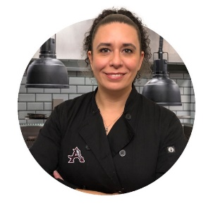
We are confident that you will find AHS Raiders Culinary to be a supportive and enriching environment where you can thrive. We look forward to getting to know you and working with you to help you reach your goals.

Sincerely,
Chef Karla Estrada

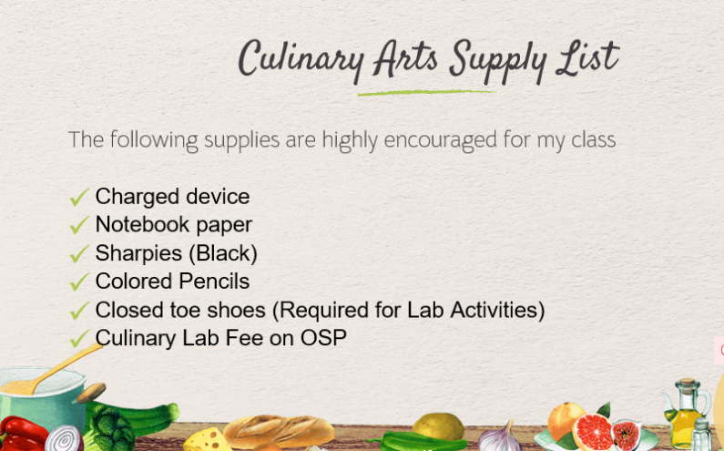
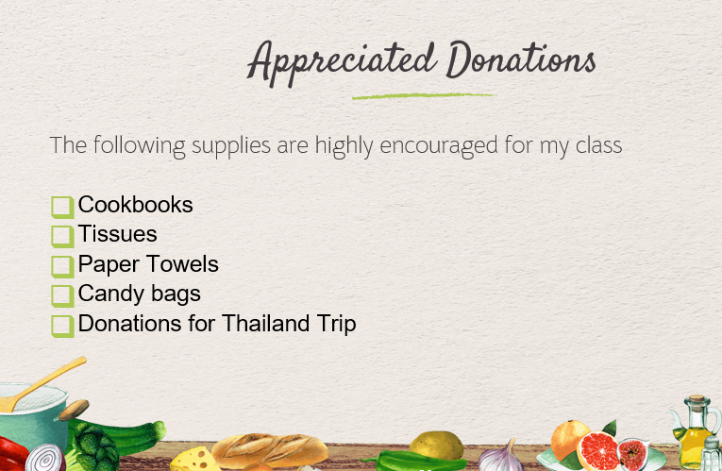
Supplies and Donations

